Minutes
  - Lebanon Town Board Meeting Via Zoom
October 12, 2020, at 7:30 pm Meeting, called to order by, Supervisor James Goldstein

In Attendance:
Supervisor James Goldstein
Council Adam Carvell
Council Patricia Matson
Highway Superintendent Alex Hodge
Town Clerk Joann Collins
Absent:
Council Marie Morgan
Council Chadwick Nower
Bookkeeper Elaina Morgan
__0_ Residents in Attendance

The Privilege of the Floor:
Privilege waived

APPROVAL OF MINUTES:
The minutes from September 14 ,2020 meeting was Approved
Roll Call: Carvell Aye, Nower Abs, Morgan Abs, Matson Aye Goldstein Aye
On motion of Council Patricia Matson
Seconded by Council Adam Carvell
Dated: October 12, 2020

Payment of Bills & Claims:
The bills & claims were reviewed, Additions were added
Approved, 10/12/2020
Roll Call: Nower Abs, Carvell Aye, Morgan Abs, Matson Aye, Goldstein Aye
On Motion of Council Adam Carvell
Seconded by Council Patricia Matson

Town Officer Reports:
Planning Board: Lois Hartshorn Chair – Present
No Activity
Board of Appeals: John Grossman Chair- Present
Nothing
Town Justice: Brian Forsythe- Present
We have a new temporary justice – Henry Moore from the Village of Earlville
Dog Control: Gordon Baker
Report Submitted.
Code Enforcement Officer: Aaron Camp- Present
Report Submitted
Aaron discussed his report
Aaron also stated that the State suggests that the town appoint an alternate code enforcement. He suggested Larry Cesario. The Town Board agreed. A resolution will be done later in the meeting.
Town Assessor: Brian Fitts
Brian handed in his budget
Town Clerk Joann Collins – Present
Report Submitted
Town Clerk asked about the front door being replaced, Alex will get three quotes for installation.

Highway Superintendent: Alex Hodge: Present
Got all sand that we need
Working on salt. The salt price is the same as last year.
One truck is up to Syracuse they are still waiting on the parts
Cutting brush and trees. We had a storm last week, South Lebanon got hit the hardest.
Trying to get plow equipment ready

Town Supervisor: James Goldstein:
Discussed Financials
Supervisor Goldstein stated that the Town got 97,000 back from CHIPS program
The Town id trying to get the AUD done.
Supervisor Goldstein stated that the sales tax will not as bad as Madison County anticipated which is good news.
COVID-19 there are 7 cases in Madison County right now.
Supervisors reported Approved
On Motion of Council Adam Carvell
Seconded by Council Patricia Matson
October 12, 2020

RESOLUTIONS:

RESOLUTION # 68-2020 ADOPTION OF THE 2021 TOWN OF LEBANON PRELIMINARY BUDGET

THEREFORE, that the Lebanon Town Board accepts the Budget officer’s Tentative Budget for 2021 as the Town of Lebanon preliminary budget for 2021 and schedules the aforementioned budget workshop and public hearing on the 2021 preliminary budget,and directs the Town Clerk to appropriately advertise these meetings in accordance with Town Law,posting Zoom links on the town website and making copies of the preliminary budget savailable to the public on request.
On Motion of Council Patricia Matson
Seconded by Council Adam Carvell
Roll Call: Nower Abs, Carvell Aye, Morgan Abs, Matson Aye, Goldstein Aye
Approved, 10/12/2020

RESOLUTION # 69-2020 FUND TRANSFER FOR 2020 BUDGET

THEREFORE BE IT RESOLVED , that the Lebanon Town Board approves the following fund transfers:
GENERAL FUND:

Transfer $ 1000 fromA1990.4 Contingency to A1410.4 Town Clerk Contractual
Increase A1410.4 from $ 700 to $ 1,700
Decrease A1990.4 Contingency from $ 10,000 to $ 9,000

On Motion of Supervisor Goldstein
Seconded by Council Adam Carvell

Vote:
Carvell _Yes__ Matson _Yes__ Morgan _Abs__ Nower _Abs__ Goldstein _Yes__

Approved _X___ Defeated ____

Dated: Oct. 12, 2020

RESOLUTION NO. 70-2020_APPOINTMENT OF PLANNING BOARD MEMBER

WHEREAS, the Town of Lebanon has a vacancy on the planning board due to the resignation of Daniel Leete,
NOW THEREFORE BE IT RESOLVED, that the Town of Lebanon Town Board appoints planning board alternate Lori Chlad to the Town of Lebanon planning board as a regular member to complete the term of Daniel Leete as a member of the planning board.
On Motion Of _ Council Patricia Matson
Chadwick Nower, Council, Personnel Chair- Absent
Seconded by ___Council Adam Carvell
Vote:
Carvell _Yes__ Matson _Yes__ Morgan _Abs__ Nower _Abs__ Goldstein _Yes__

Approved _X___ Defeated ____

Dated: Oct. 12, 2020

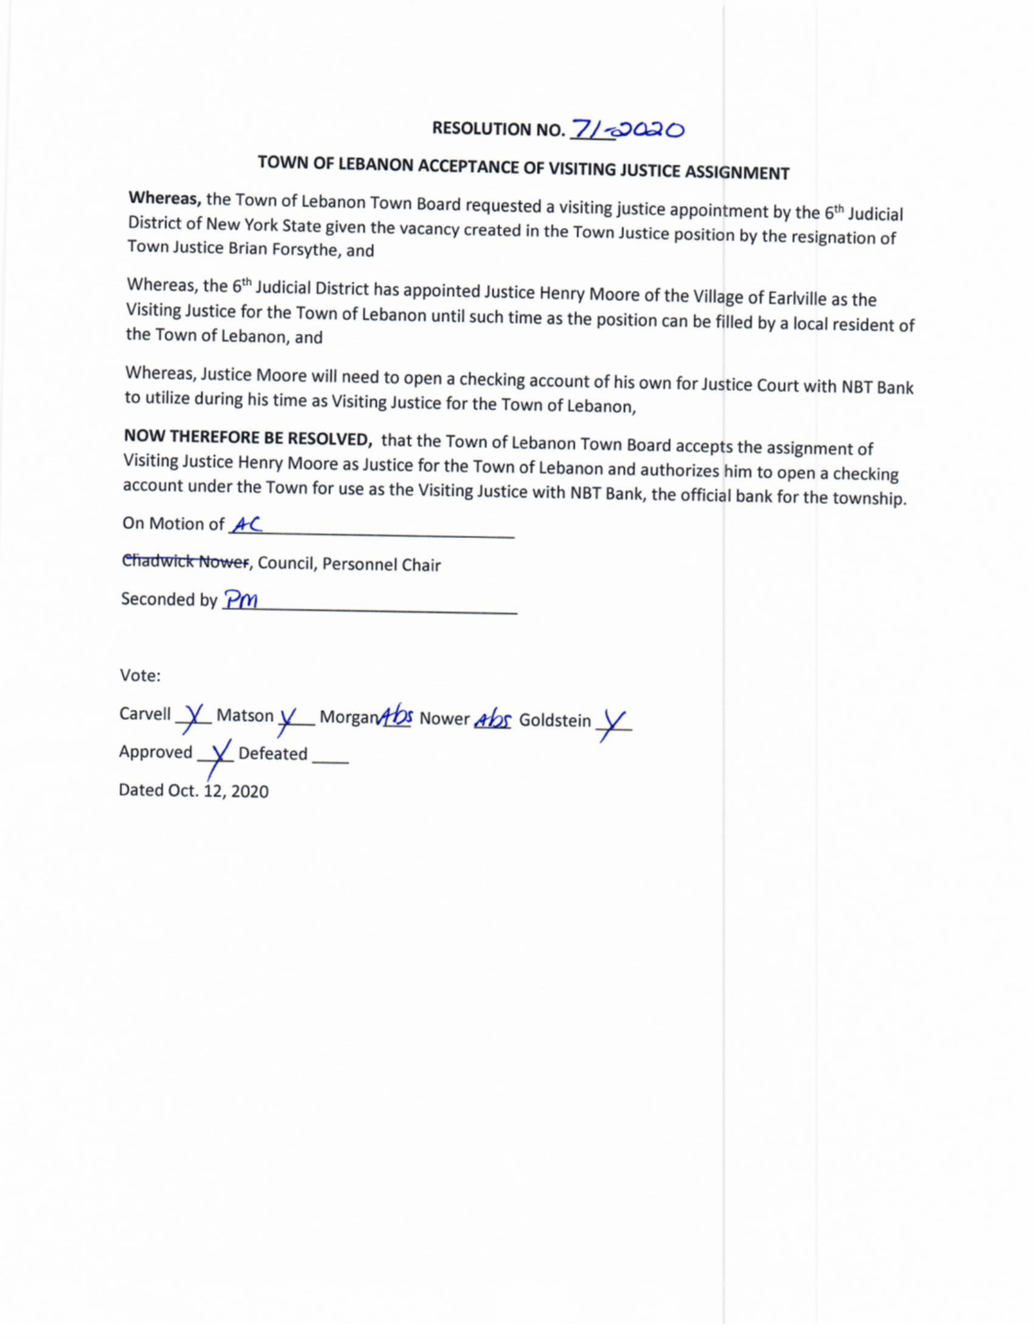
RESOLUTION # 72-2020 AUTHORIZING TOWN SUPERVISOR TO ENTER INTO AGREEMENT WITH NYSEG TO UPGRADE LIGHTING DISTRICT IN HAMLET OF LEBANON WITH NEW LED LIGHTING SYSTEM

NOW THEREFORE BE IT RESOLVED, that the Town of Lebanon Town Board authorizes the Town Supervisor in consultation with Attorney for the Town to enter into a letter of agreement with New York State Electric and Gas Inc after negotiating the most favorable financial arrangement for the township which the Town Supervisor will keep Town Board members advised of prior to any final contract.

On Motion Of _ Council Patricia Matson
Seconded by ___Council Adam Carvell
Vote:
Carvell _Yes__ Matson _Yes__ Morgan _Abs__ Nower _Abs__ Goldstein _Yes__

Approved _X___ Defeated ____

Dated: Oct. 12, 2020

RESOLUTION # 73-2020 AUTHORIZING THE ADERTISEMENT AND SOLICITATION OF BIDS FOR COLD STORAGE BUILDING

THERFORE BE IT RESOLVED, that the Town of Lebanon Town Board hereby directs the advertisement of bids for the furnishing and installation of an approximately 32 fooy x 60 foor cold storage pole barn – style structure on the existing floor slab in accordance with all applicable New York State Building Code Requirements, The plans and drawings of Roberts Engineering, PLLC , stamped and dated September 29,2020 , as last amended,and the issuanace of bid documents for response to said bids, with a bidder return date and bid opening on November 5 2020, at which time any responsive bids shall be publicly opened and read aloud: and it is further
RESOLVED, that said bid documentation shall reserve the right of the Town of Lebanon to reject all bids to rebid the project at the Town Board’s sole discretion.

On Motion Of _ Council Patricia Matson
Seconded by ___Council Adam Carvell
Vote:
Carvell _Yes__ Matson _Yes__ Morgan _Abs__ Nower _Abs__ Goldstein _Yes__

Approved _X___ Defeated ____

Dated: Oct. 12, 2020

RESOLUTION OF ALTERNATE CODE ENFORCEMENT OFFICER FOR THE TOWN OF LEBANON

THEREFORE, BE IT RESOLVED , the Town of Lebanon Town Board appoints Larry Cesario of the Town of Eaton , a certified code enforcement officer, to the duties of alternate Code Enforcement Officer for the Town of Lebanon at an annual stiped of $ 400.

On Motion Of _ Council Adam Carvell
Seconded by ___Council Patricia Matson
Vote:
Carvell _Yes__ Matson _Yes__ Morgan _Abs__ Nower _Abs__ Goldstein _Yes__

Approved _X___ Defeated ____

Dated: Oct. 12, 2020

RESOLUTION NO.__74-2020__APPOINTMENT OF ALTERNATE CODE ENFORCEMENT OFFICER FOR THE TOWN OF LEBANON

WHEREAS, the Town of Lebanon will require the services of an alternative code enforcement office when conflicts of interest arise with the present Code Enforcement Officer,

THEREFORE, BE IT RESOLVED, the Town of Lebanon Town Board appoints Larry Cesario of the Town of Eaton, a certified code enforcement officer, to the duties of alternate Code Enforcement Officer for the Town of Lebanon at an annual stipend of $400.
On Motion of Adam Carvell, Council
Seconded by Patricia Matson, Council
Vote:
Carvell _Yes__ Nower _Abs__ Morgan _Abs__ Matson _Yes__ Goldstein _Yes__
Approved _X__ Defeated ____
Dated: Oct. 12, 2020

DISCUSSION ITEMS:
Discussion was raised by Council Patricia Matson on considering options for SOMAC contract that allow town to be billed for actual expenses vs contractual rate quarterly. Contract to be reviewed by Attorney Langley but if numbers work for town, town board will consider at the upcoming budget workshop. The Town of Hamilton presently has this arrangement according to Council Matson and has not been billed for the full amount of their contract the last two years as it is based on actual expenditures.
Supervisor Goldstein had Attorney Langley review the ways in which the Town Board must comply with public hearing requirements under COVID-19 limitations when holding a Zoom meeting. The Zoom link for video and phone should be included in any advertisement for the hearing.
The Town Clerk needs to post a Zoom link for the public hearing. It needs to be published in the paper and put on the website. Also, on the building it needs to be posted.
Supervisor Goldstein will send out a notice to all his residents on his email list.

The Town Board will meet Via Zoom for the Budget Workshop on Oct 26 at 7:30 pm.
There will be a Public Hearing for the Town Budget on November 5 at 8:00 pm, Also there will be a meeting for the bids for the Cold storage building for the Highway. The bids will be opened then.

Next Meeting
11/9/2020, Via Zoom
The motion to adjourn was made by Council Adam Carvell and Seconded by Council Patricia Matson at 8:30pm.

Respectfully Submitted,

Joann L Collins
Recording Town Clerk

